**Provide machine name**

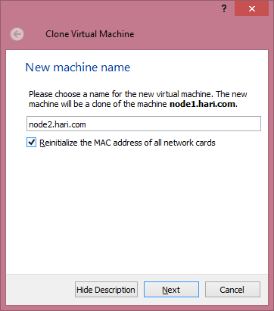

**Select full clone**

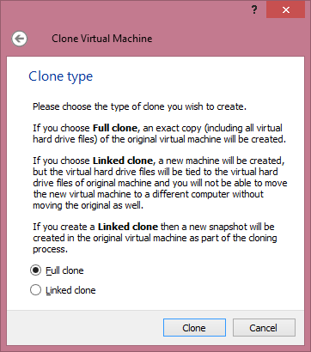

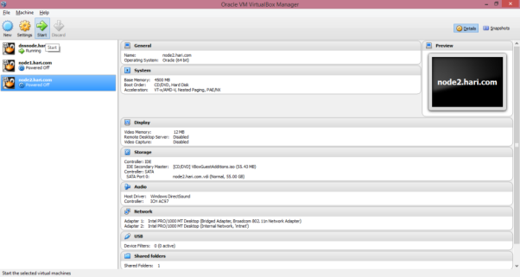

**Configure network as below**

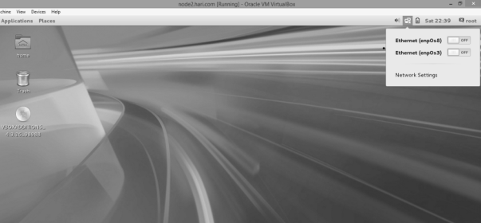

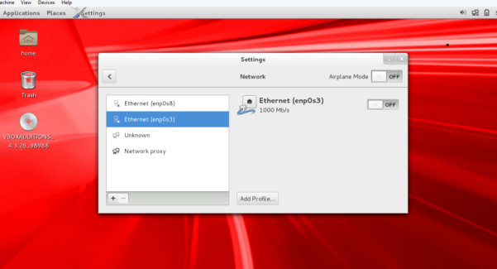

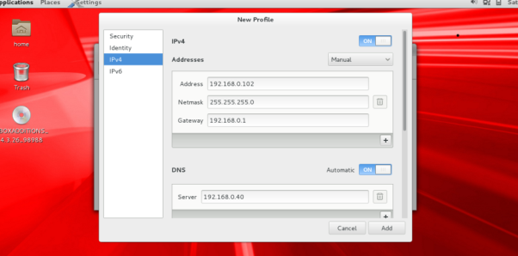

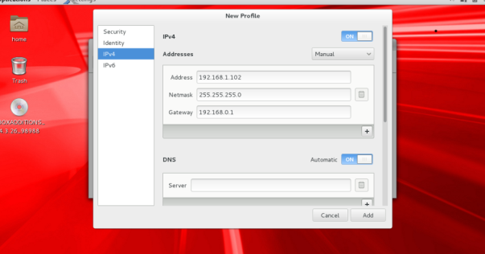

**Set hostname to node2**

[root@node1 ~]# hostnamectl set-hostname node2.hari.com

[root@node2 ~]# hostname

node2.hari.com

**Follow below steps to configure shared storage for cluster registry and voting disk**

**Goto storage on node1 settings**

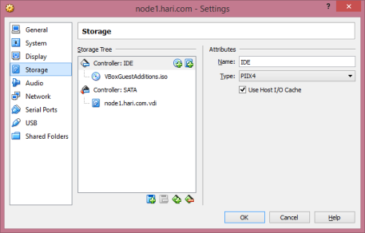

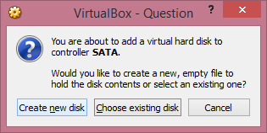

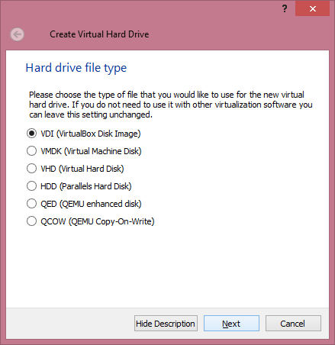

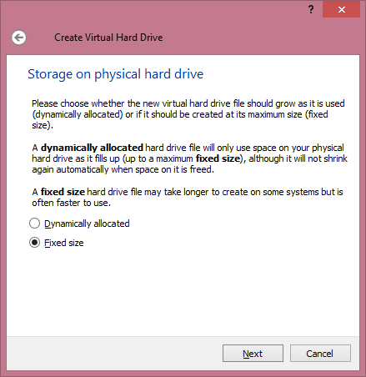

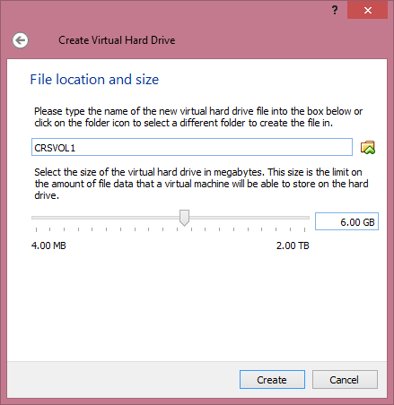

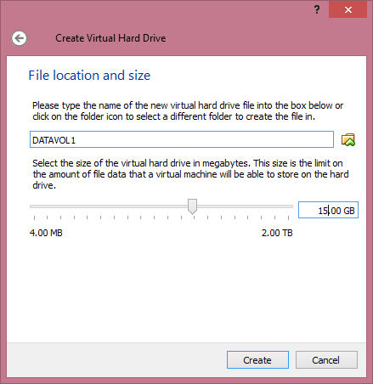

**Goto File (Virtual Media Manager)**

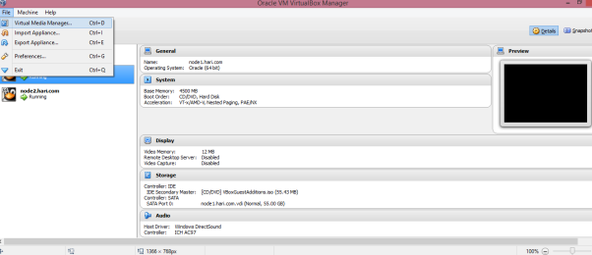

**Select VDI created above and make it shareable**

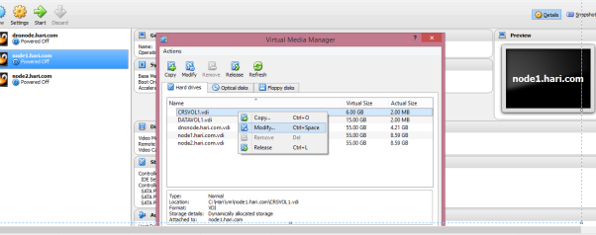

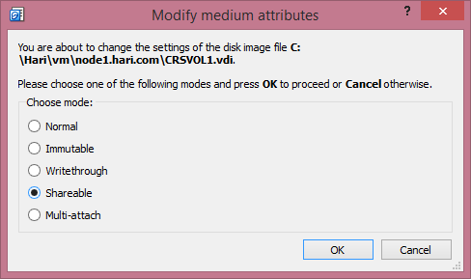

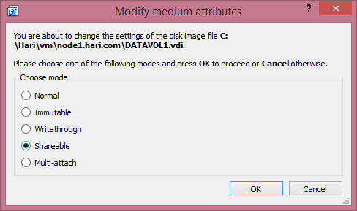

**For node2 add shared disk**

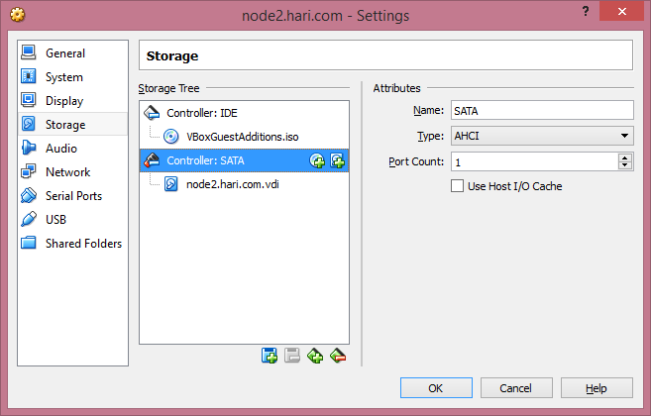

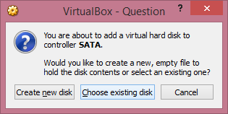

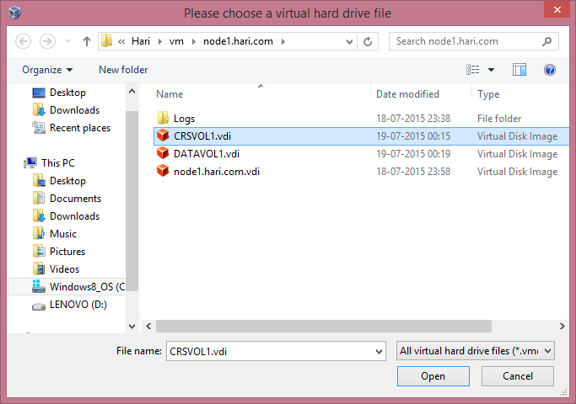

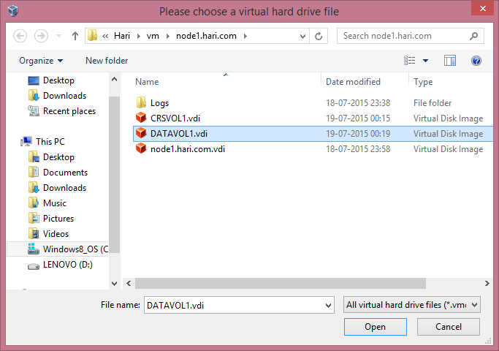

**Login to node1 and you can see below disks visible**

[root@node1 ~]# ls -tplr /dev/sd*

brw-rw---- 1 root disk 8, 16 Jul 19 00:24 /dev/sdb

brw-rw---- 1 root disk 8, 32 Jul 19 00:24 /dev/sdc

brw-rw---- 1 root disk 8, 0 Jul 19 00:24 /dev/sda

brw-rw---- 1 root disk 8, 2 Jul 19 00:24 /dev/sda2

brw-rw---- 1 root disk 8, 1 Jul 19 00:24 /dev/sda1

[root@node1 ~]# fdisk /dev/sdb

Welcome to fdisk (util-linux 2.23.2).

Changes will remain in memory only, until you decide to write them.

Be careful before using the write command.

Device does not contain a recognized partition table

Building a new DOS disklabel with disk identifier 0x5b9074e1.

Command (m for help): n

Partition type:

p primary (0 primary, 0 extended, 4 free)

e extended

Select (default p): p

Partition number (1-4, default 1):

First sector (2048-12582911, default 2048):

Using default value 2048

Last sector, +sectors or +size{K,M,G} (2048-12582911, default 12582911):

Using default value 12582911

Partition 1 of type Linux and of size 6 GiB is set

Command (m for help): p

Disk /dev/sdb: 6442 MB, 6442450944 bytes, 12582912 sectors

Units = sectors of 1 * 512 = 512 bytes

Sector size (logical/physical): 512 bytes / 512 bytes

I/O size (minimum/optimal): 512 bytes / 512 bytes

Disk label type: dos

Disk identifier: 0x5b9074e1

Device Boot Start End Blocks Id System

/dev/sdb1 2048 12582911 6290432 83 Linux

Command (m for help): w

The partition table has been altered!

Calling ioctl() to re-read partition table.

Syncing disks.

**Repeat above for datavol disk**

[root@node1 ~]# fdisk /dev/sdc

**Install Oracleasm-support RPM**

[root@node1 ~]# yum install oracleasm-support -y

Loaded plugins: langpacks

Resolving Dependencies

.

.

Installed:

oracleasm-support.x86_64 0:2.1.8-3.el7

Complete!

**Configure oracleasm**

[root@node1 ~]# /usr/sbin/oracleasm configure -i

Configuring the Oracle ASM library driver.

This will configure the on-boot properties of the Oracle ASM library

driver. The following questions will determine whether the driver is

loaded on boot and what permissions it will have. The current values

will be shown in brackets ('[]'). Hitting <ENTER> without typing an

answer will keep that current value. Ctrl-C will abort.

Default user to own the driver interface []: grid

Default group to own the driver interface []: asmadmin

Scan for Oracle ASM disks on boot (y/n) [y]:

Writing Oracle ASM library driver configuration: done

**Initialize oracleasm**

[root@node1 ~]# /usr/sbin/oracleasm init

Creating /dev/oracleasm mount point: /dev/oracleasm

Loading module "oracleasm": oracleasm

Configuring "oracleasm" to use device physical block size

Mounting ASMlib driver filesystem: /dev/oracleasm

**Create asm disk for crsvol**

[root@node1 ~]# /usr/sbin/oracleasm createdisk CRSVOL1 /dev/sdb1

Writing disk header: done

Instantiating disk: done

**Create asm disk for datavol**

[root@node1 ~]# /usr/sbin/oracleasm createdisk DATAVOL1 /dev/sdc1

Writing disk header: done

Instantiating disk: done

[root@node1 ~]# /usr/sbin/oracleasm scandisks

Reloading disk partitions: done

Cleaning any stale ASM disks...

Scanning system for ASM disks...

**Setup SSH user equivalence**

[grid@node1 sshsetup]$ ./sshUserSetup.sh -user grid -hosts "node1 node2" -noPromptPassphrase

The output of this script is also logged into /tmp/sshUserSetup_2015-07-19-00-35-51.log

Hosts are node1 node2

**Unzip grid install software and start runinstaller from grid user**

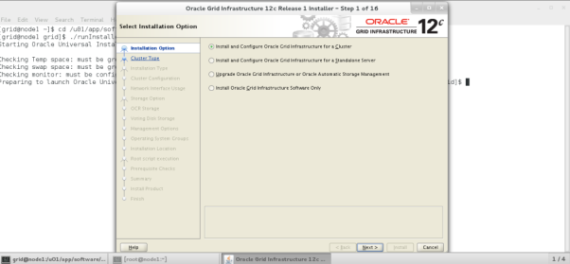

**Select Standard Cluster**

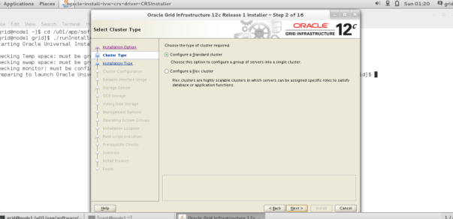

**Select Advanced Install**

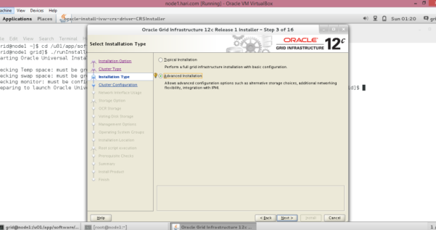

**Select English**

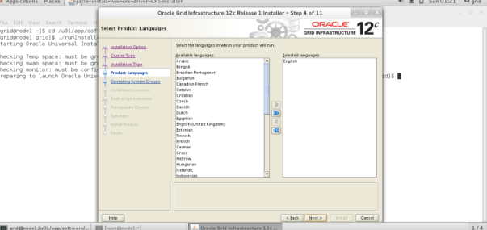

**Provide cluster name and SCAN details, since we are using DNS it is not required to use GNS**

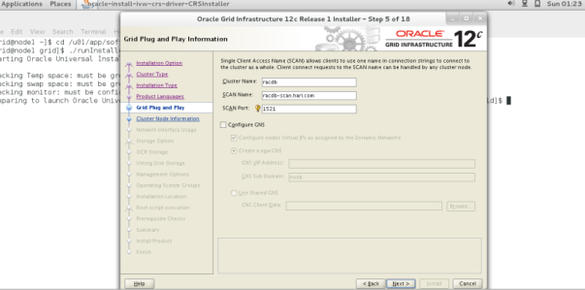

**Add Node2 details and do the test SSH**

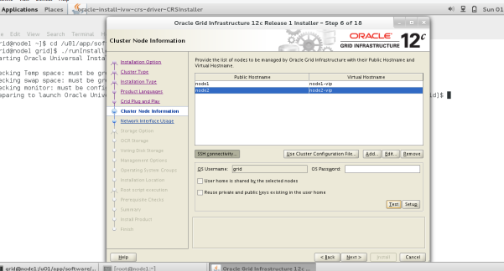

**Make s8 to be private interface**

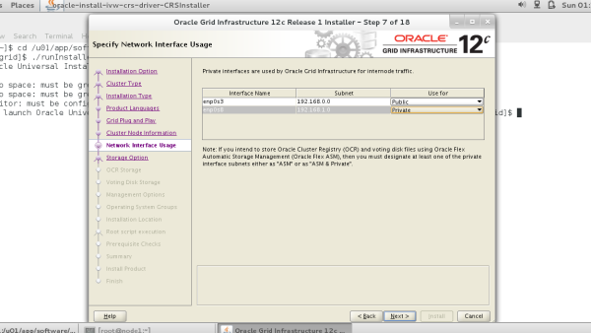

**Select Standard ASM storage**

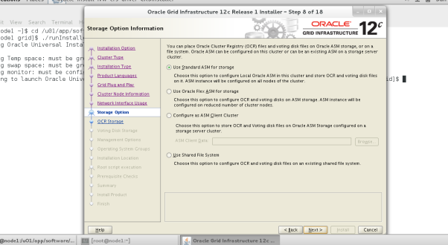

**Select all candidate disk and name disk group, If disk not visible use discovery path**

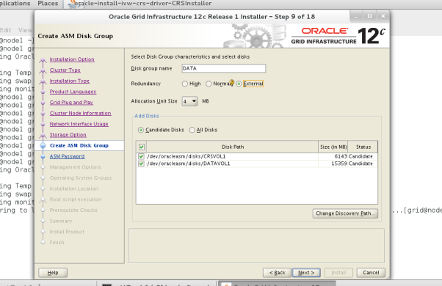

**Provide password**

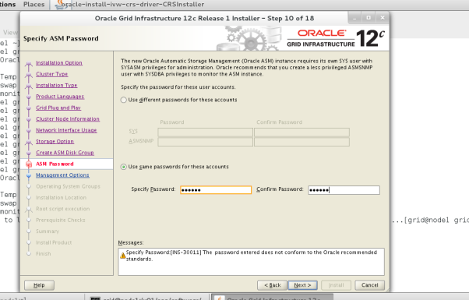

**Select do not use IPMI**

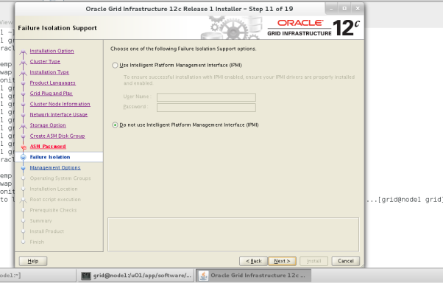

**If using EM cloud control provide below details else Next**

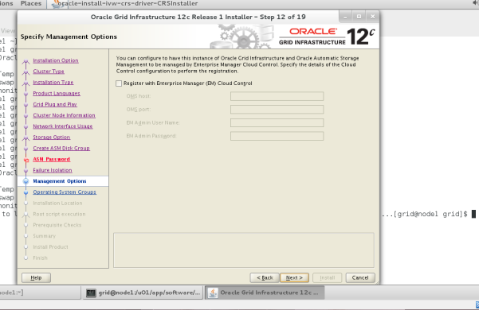

**Select ASM operating system groups**

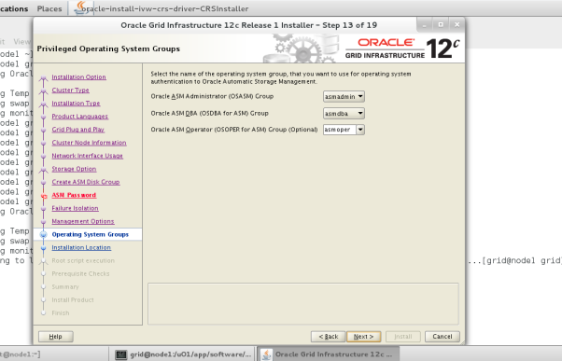

**Choose path for grid installation directory**

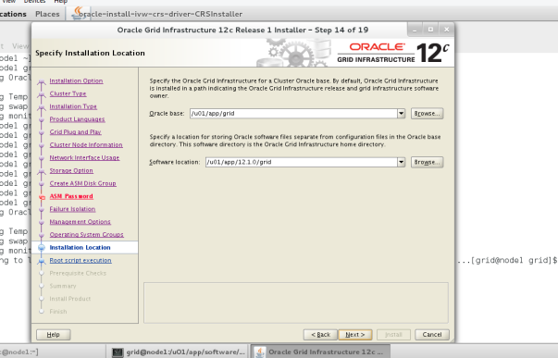

**Choose path for inventory**

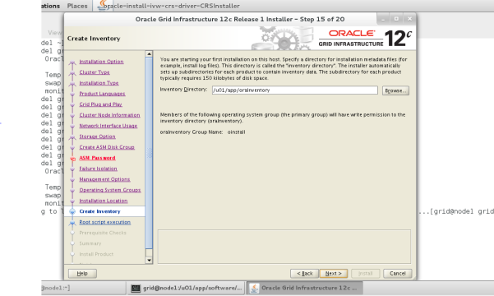

**Choose if you have sudo option or root password**

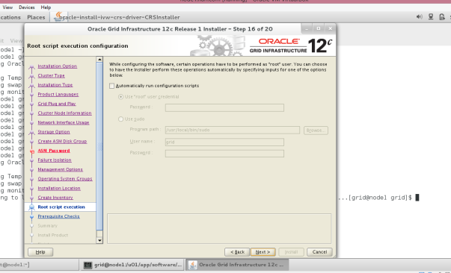

**Check for warning or failures and fix**

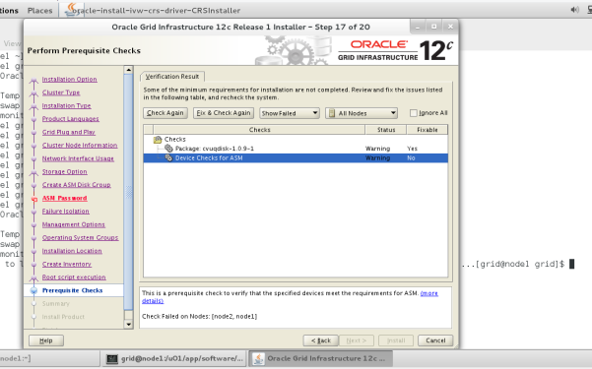

**Install cvuqdisk RPM**

[root@node1 rpm]# rpm -ivh cvuqdisk-1.0.9-1.rpm

Preparing... ################################# [100%]

Using default group oinstall to install package

Updating / installing...

1:cvuqdisk-1.0.9-1 ################################# [100%]

**Check again and proceed with install**

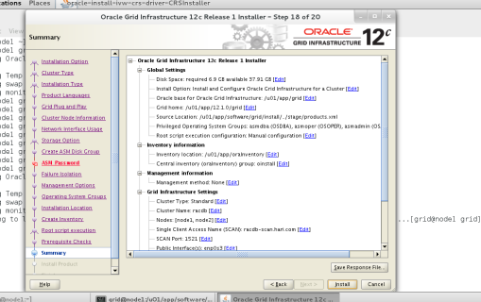

**Run orainstRoot.sh and root.sh in the order specified to complete install**

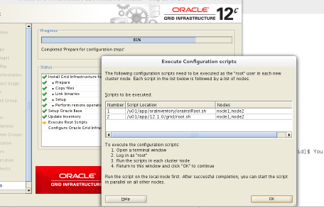

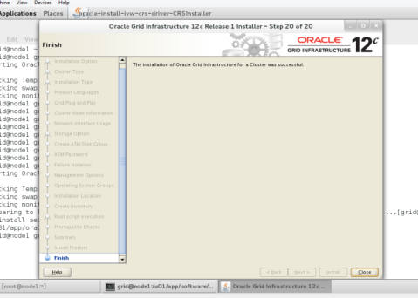

**Unzip database software and start runInstaller**

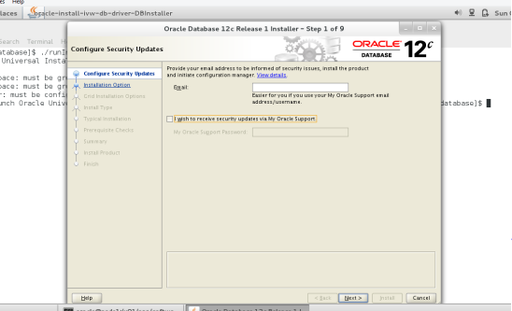

**Choose Create and configure database**

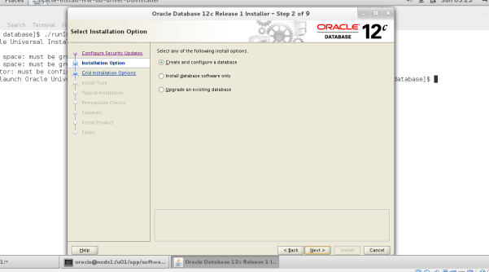

**Choose Server Class**

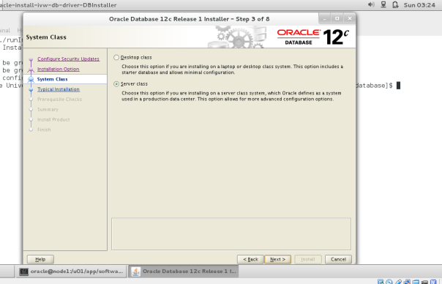

**Choose Oracle RAC install**

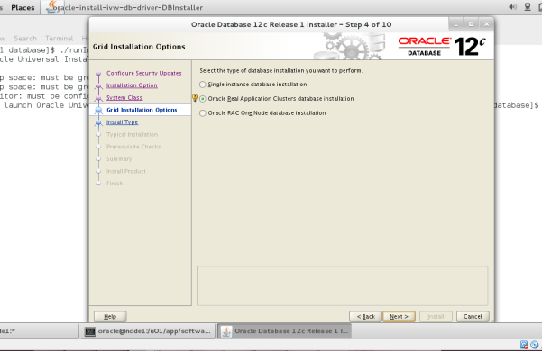

**Choose Admin Managed**

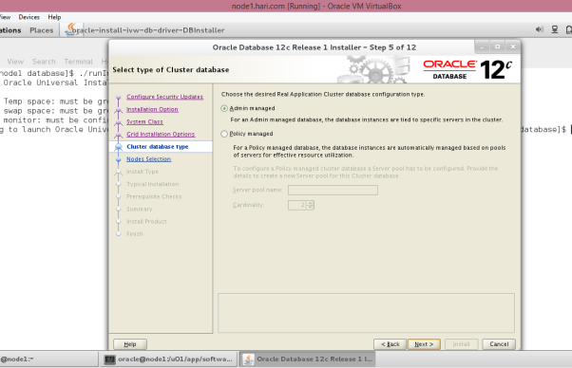

**Enable ssh connectivity for Oracle user**

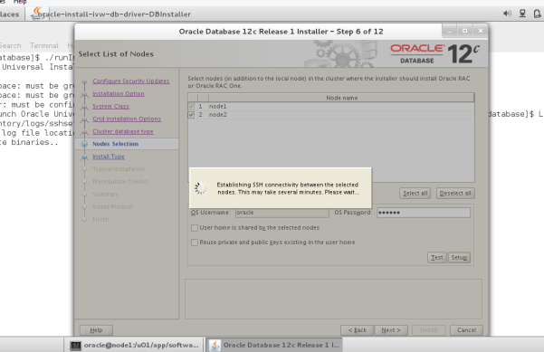

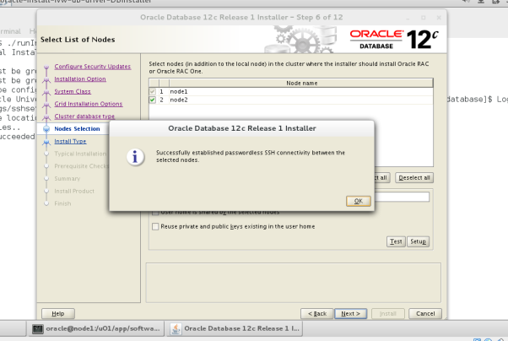

**Choose Advanced install**

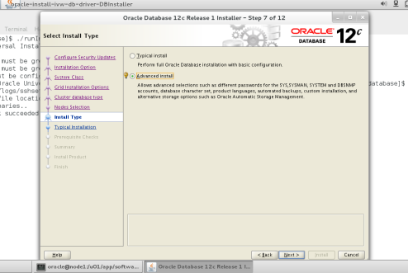

**Choose English**

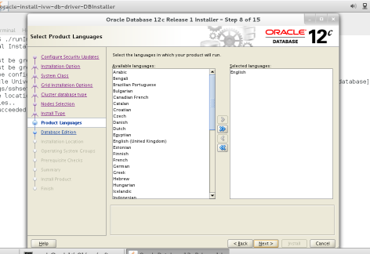

**Choose Enterprise Edition**

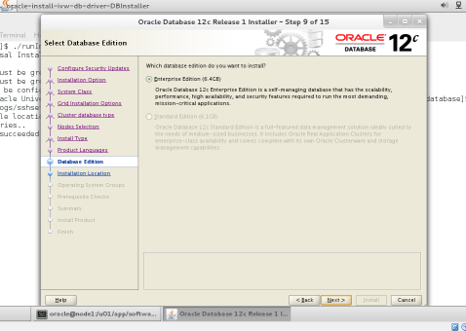

**Provide Oracle base and Software location**

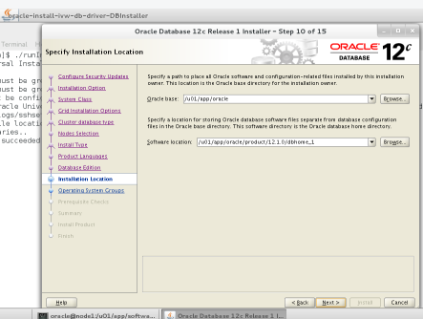

**Select General Purpose/Transaction processing**

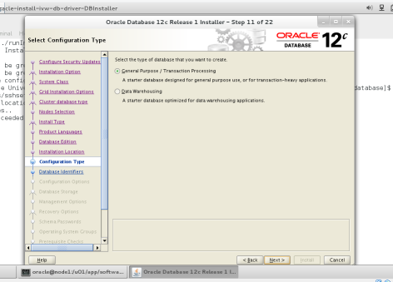

**Provide database and PDB details**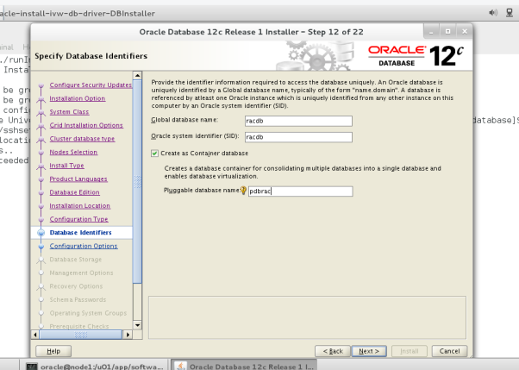

**Set memory, Character set and sample schemas if needed**

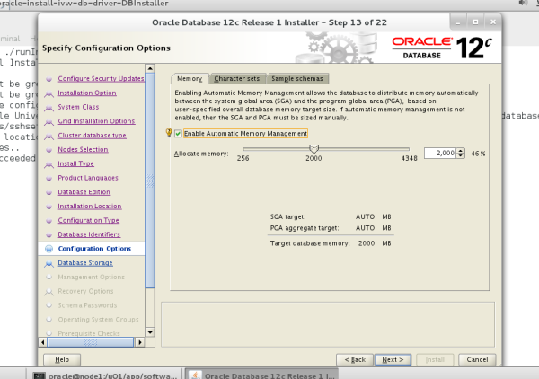

**Choose ASM**

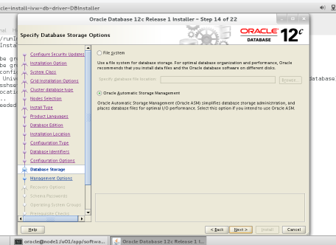

**No EM is used, Click on Next**

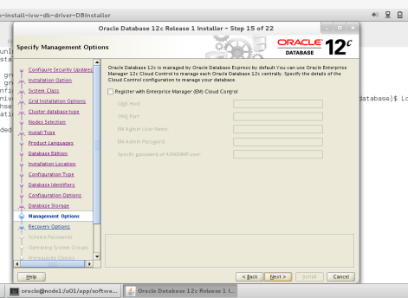

**Provide is using recovery option**

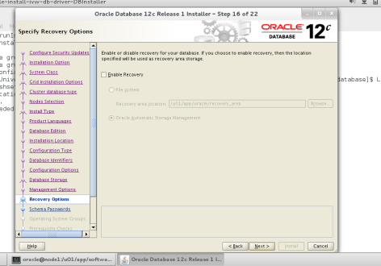

**Select disk group**

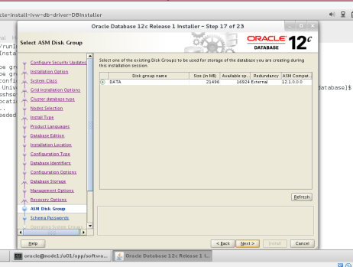

**Provide password**

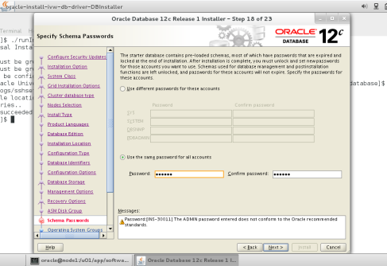

**Check and Modify below group information if necessary**

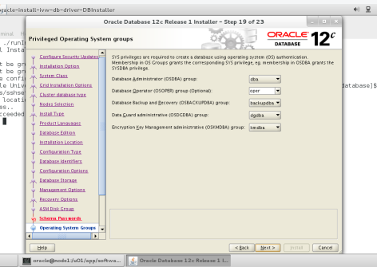

**Check Ignore all, But make sure tmpfs is more than size of database memory**

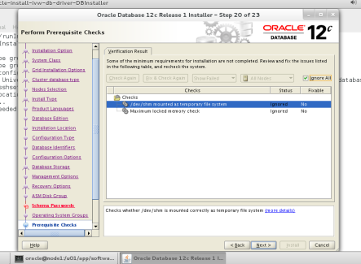

**Start Install**

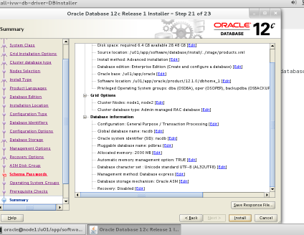

**Run root.sh on node1 & node2 in the order mentioned**

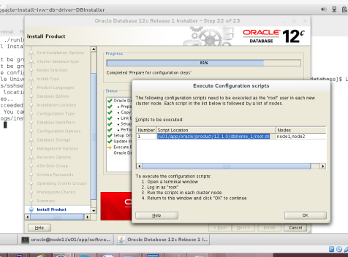

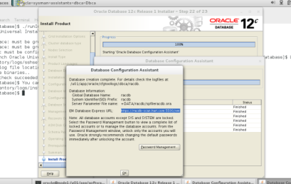

**Complete installation**

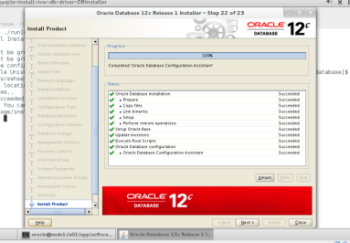

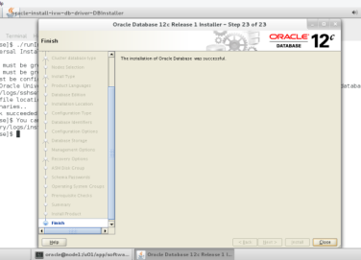

**Run crsctl stat to check**

[grid@node1 ~]$ crsctl stat res -t

--------------------------------------------------------------------------------

Name Target State Server State details

--------------------------------------------------------------------------------

Local Resources

--------------------------------------------------------------------------------

ora.DATA.dg

ONLINE ONLINE node1 STABLE

ONLINE ONLINE node2 STABLE

ora.LISTENER.lsnr

ONLINE ONLINE node1 STABLE

ONLINE ONLINE node2 STABLE

ora.asm

ONLINE ONLINE node1 Started,STABLE

ONLINE ONLINE node2 Started,STABLE

ora.net1.network

ONLINE ONLINE node1 STABLE

ONLINE ONLINE node2 STABLE

ora.ons

ONLINE ONLINE node1 STABLE

ONLINE ONLINE node2 STABLE

--------------------------------------------------------------------------------

Cluster Resources

--------------------------------------------------------------------------------

ora.LISTENER_SCAN1.lsnr

1 ONLINE ONLINE node1 STABLE

ora.LISTENER_SCAN2.lsnr

1 ONLINE ONLINE node2 STABLE

ora.LISTENER_SCAN3.lsnr

1 ONLINE ONLINE node1 STABLE

ora.MGMTLSNR

1 ONLINE ONLINE node2 169.254.65.53 192.16

8.1.102,STABLE

ora.cvu

1 ONLINE ONLINE node2 STABLE

ora.mgmtdb

1 OFFLINE OFFLINE STABLE

ora.node1.vip

1 ONLINE ONLINE node1 STABLE

ora.node2.vip

1 ONLINE ONLINE node2 STABLE

ora.oc4j

1 ONLINE ONLINE node2 STABLE

ora.racdb.db

1 ONLINE ONLINE node1 Open,STABLE

2 ONLINE ONLINE node2 Open,STABLE

ora.scan1.vip

1 ONLINE ONLINE node1 STABLE

ora.scan2.vip

1 ONLINE ONLINE node2 STABLE

ora.scan3.vip

1 ONLINE ONLINE node1 STABLE

--------------------------------------------------------------------------------

## Check gv$instance

SQL> select * from gv$instance;

INST_ID INSTANCE_NUMBER INSTANCE_NAME HOST_NAME VERSION STARTUP_T STATUS PAR THREAD# ARCHIVE LOG_SWITCH_WAIT

---------- --------------- ---------------- ---------------------------------------------------------------- ----------------- --------- ------------ --- ---------- ------- ---------------

LOGINS SHU DATABASE_STATUS INSTANCE_ROLE ACTIVE_ST BLO CON_ID INSTANCE_MO EDITION FAMILY

---------- --- ----------------- ------------------ --------- --- ---------- ----------- ------- --------------------------------------------------------------------------------

1 1 racdb1 node1.hari.com 12.1.0.2.0 19-JUL-15 OPEN YES 1 STOPPED

ALLOWED NO ACTIVE PRIMARY_INSTANCE NORMAL NO 0 REGULAR EE

2 2 racdb2 node2.hari.com 12.1.0.2.0 19-JUL-15 OPEN YES 2 STOPPED

ALLOWED NO ACTIVE PRIMARY_INSTANCE NORMAL NO 0 REGULAR EE